Classical Fourth Order Runge-Kutta (RK4) Method 1
Plot: Position vs Time 2
Plot: Velocity vs Time with Max Speed 2
Plot: Position vs Time and elocity vs Time with Max Speed 3
clear; close all; clc;
% Parameters
H = 74; D = 31; c = 0.9; m = 80; L = 25; k = 90; g = 9.8;
%scaled parameters
C = c/m;
K = k/m;
dt = 0.01; % time step
T = 60; % total time
N = T/dt; % number of steps
y = zeros(1, N); v = zeros(1, N); % Initialize position and velocity
y(1) = 0; % Initial position

Classical Fourth Order Runge-Kutta (RK4) Method
for i = 1:N-1
[y(i+1), v(i+1)] = RK4_step(y(i), v(i), C, K, L, g, dt);
end
% Analysis: Number of Bounces and Timing
[~,locs] = findpeaks(-y);
bounces = length(locs);
time_for_bounces = locs(end) * dt;
fprintf('Number of bounces: %d\n', bounces);
fprintf('Time for bounces: %.2f s\n', time_for_bounces);
% Analysis: Maximum Speed and Timing
[max_speed, max_speed_idx] = max(v);
time_of_max_speed = max_speed_idx * dt;
fprintf('Maximum speed: %.2f m/s\n', abs(max_speed));
fprintf('Time of maximum speed: %.2f s\n', time_of_max_speed);
Number of bounces: 9
Time for bounces: 55.20 s
Maximum speed: 20.01 m/s
Time of maximum speed: 2.61 s

Plot: Position vs Time
figure;
plot(0:dt:(T-dt), y);
xlabel('Time (s)');
ylabel('Position (m)');
title('Position vs Time Using Modified Euler');
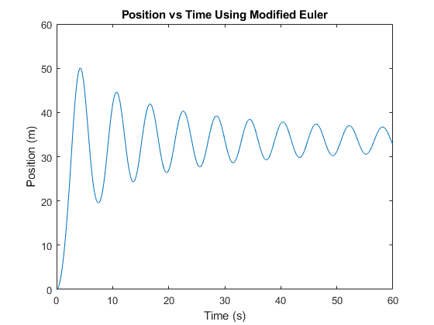

Plot: Velocity vs Time with Max Speed
figure;
plot(0:dt:(T-dt), -v);
hold on;
plot(time_of_max_speed, max_speed, 'ro');
xlabel('Time (s)');
ylabel('Velocity (m/s)');
title('Velocity vs Time');
legend('Velocity', 'Max Speed');
hold off;
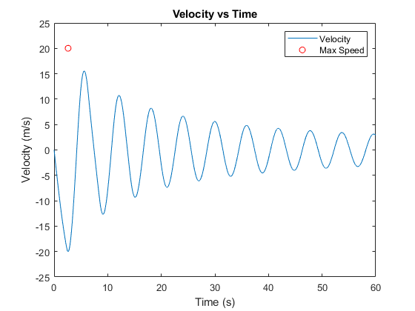

Plot: Position vs Time and elocity vs Time with Max Speed
figure;
plot(0:dt:(T-dt), y);
xlabel('Time (s)');
ylabel('Position (m)-Velocity (m/s)');
title('Position/Velocity vs Time Using Modified Euler');
hold on;
plot(0:dt:(T-dt), v);
plot(time_of_max_speed, max_speed, 'ro');
xlabel('Time (s)');
ylabel('Velocity (m/s)');
title('Velocity vs Time');
legend('Pos','Velocity', 'Max Speed');
hold off;
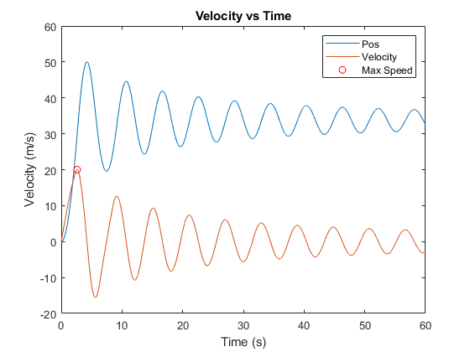
Published with MATLAB® R2021a

